MBA Academic Advisor Chatbot
Hebrew University Business School
Project Architecture, Development Progress, and Final Timeline
1. Executive Summary
The project aims to develop an intelligent academic advisor chatbot for MBA students and prospective applicants at the Hebrew University Business School. The system is designed to answer questions about admissions, study programs, specializations, course requirements, exemptions, schedules, and academic regulations.
The main challenge was that relevant academic information is spread across several official university websites, PDF documents, and the Hebrew University Shnaton system. As a result, students often need to search manually across fragmented sources to find reliable answers.
To solve this, we built a Retrieval-Augmented Generation system, or RAG system, based on Google Gemini, FAISS vector search, and official Hebrew University data sources. Unlike a normal chatbot, the system does not rely only on the model’s general knowledge. Instead, every answer is grounded in official university content that is retrieved before the model generates a response.
The project evolved in three major phases:
- Building the core chatbot architecture
- Expanding the knowledge base using Shnaton data
- Improving the user experience with personalization, onboarding, and a course schedule planner


The Team:


Name | Role | Responsibility
Roy Rubel | CEO & Data Scientist | Project leadership, business strategy, client requirements, product direction, data analysis, AI system design, and overall project management
Ram | VP Product & Marketing | Product positioning, user experience, business needs, marketing perspective, and client-facing presentation
Bar | CTO & Data Scientist | Technical architecture, system development, backend/frontend implementation, data pipeline, AI integration, and model/data validation

2. Business Problem and Client Requirements
2.1 The Problem
MBA students and applicants do not currently have a fast and reliable way to receive answers about:
- Admission requirements
- Specialization tracks
- Course requirements
- Academic exemptions
- Accelerated study tracks
- Course schedules
- Grade breakdowns
- Teacher information
The information exists, but it is fragmented across multiple official sources. Some information is available on the Business School website, some appears in PDF documents, and detailed course information is stored inside the Shnaton system.
This creates friction for students and increases dependency on academic advisors for questions that could potentially be answered automatically.
2.2 Client Requirements
The client asked for a system that could:
Requirement | Description
Intelligent Q&A chatbot | Answer student questions in Hebrew
Official-source grounding | Use official HUJI sources only
No hallucinations | Avoid invented or unsupported answers
Personalized responses | Adapt answers to student type and specialization
Course data integration | Include teachers, schedules, grades, and course details
Study planning tool | Allow students to plan courses across semesters
Professional Hebrew UI | Support right-to-left Hebrew interface

2.3 Success Criteria
The project is considered successful if:
- Answers are accurate and based on official sources
- The chatbot refuses to answer when information is not available
- The interface is easy for students to use
- The system can be updated when curriculum information changes
- The chatbot provides value beyond a regular search engine or generic AI model

Business Problem Flow
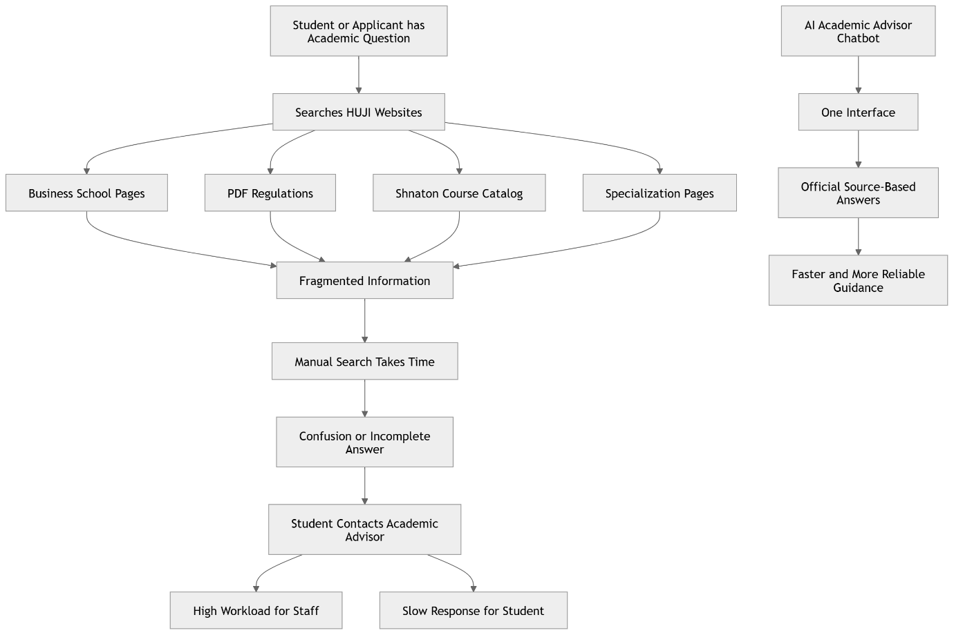

3. System Architecture Overview
The chatbot is built as a full-stack AI system. The core architectural decision was to use Retrieval-Augmented Generation instead of sending questions directly to Gemini.
A direct Gemini-only system would answer from its general training data. That creates a high risk of hallucination because specific Hebrew University MBA rules may not be stored accurately in the model’s training data.
Instead, our system first searches official university content, retrieves the most relevant text chunks, and only then asks Gemini to generate an answer based on that retrieved context.

Layer | Technology | Purpose
Backend | FastAPI + Uvicorn | Async API server
LLM | Google Gemini 2.5 Flash | Hebrew answer generation
Embeddings | gemini-embedding-001 | Convert text into semantic vectors
Vector Database | FAISS IndexFlatIP | Fast similarity search
Scraping | Playwright + Requests | Extract official HUJI content
Frontend | HTML, CSS, JavaScript | Lightweight Hebrew chat interface
Markdown Rendering | marked.js | Render formatted answers in chat
Data Cache | Local cache | Avoid unnecessary scraping and provide fallback

High-Level System Architecture
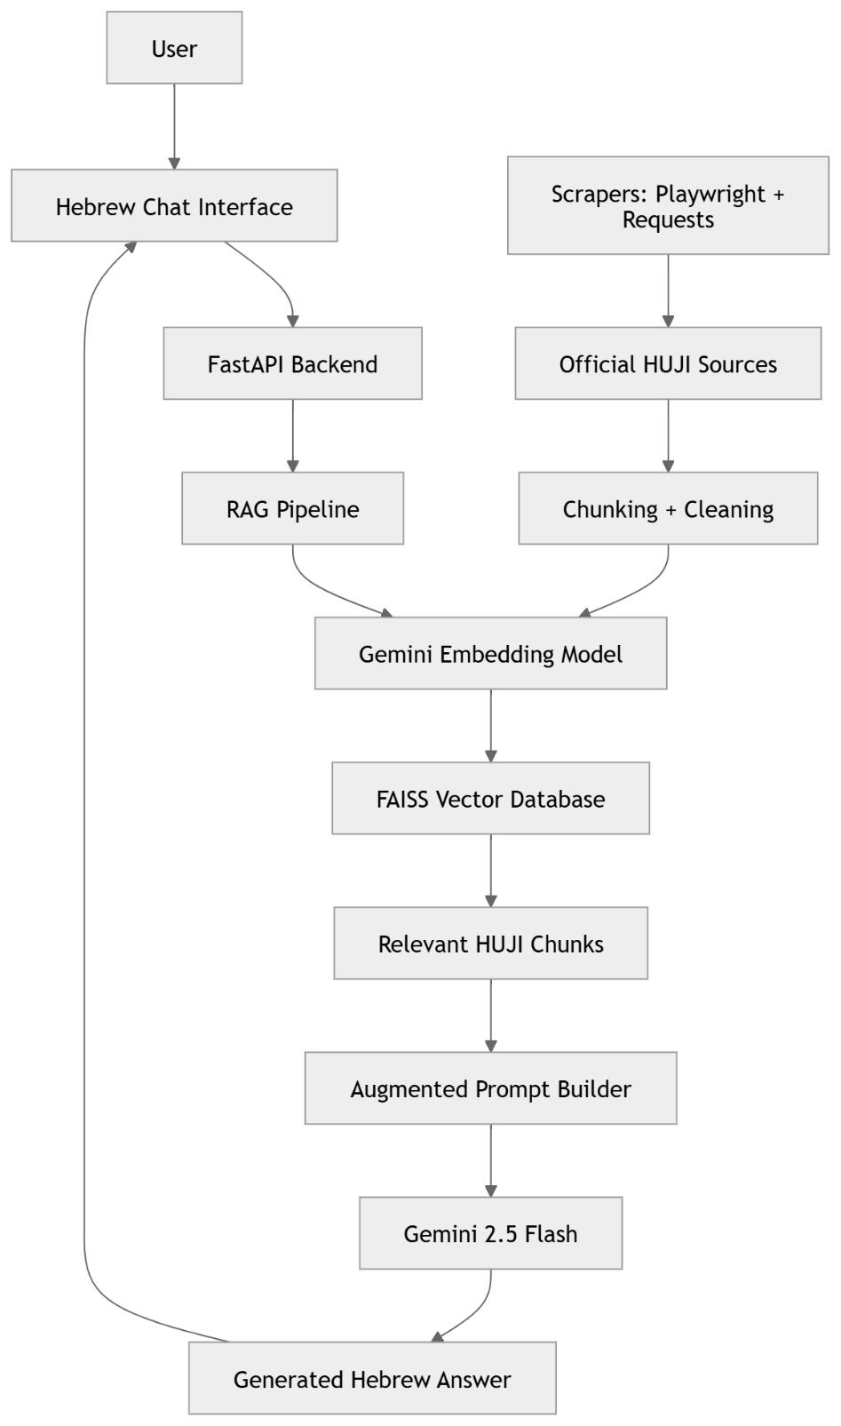

5. RAG Pipeline Explanation
The RAG pipeline is the core of the system. It ensures that the chatbot answers only using information retrieved from official sources.
The process works as follows:
- The user asks a question in Hebrew
- The question is embedded using the Gemini embedding model
- The system searches the FAISS vector database
- The top relevant chunks are retrieved
- If no relevant source is found, the chatbot refuses to answer
- The retrieved text is inserted into the prompt
- Gemini generates a final answer based only on the retrieved context
- The answer is returned to the user in Hebrew
This architecture reduces hallucinations because Gemini is not expected to “know” the answer from memory. It is asked to reason over official university text that was retrieved at runtime.

RAG Pipeline Diagram:
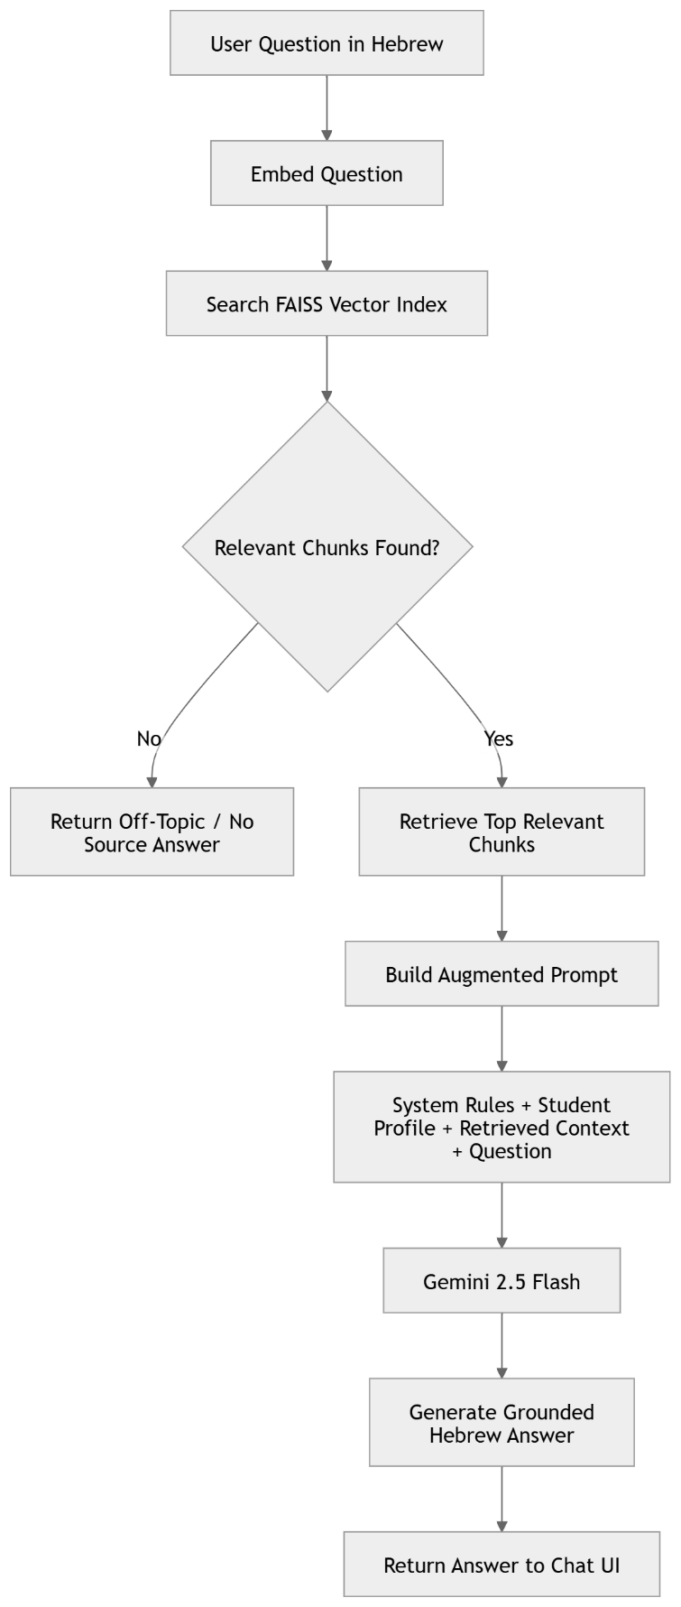

6. Phase 1 — Core Architecture
Timeline: Weeks 1–3
The first phase focused on building the technical foundation of the system.
6.1 What Was Built
During this phase, we built:
- FastAPI backend server
- Gemini API integration
- Embedding pipeline
- FAISS vector database
- Initial scraper for official HUJI pages
- Basic Hebrew chat interface
- Session history
- Off-topic detection
- Citation verification logic
- Rate limiting
6.2 Initial Data Sources
The first version included official content from:
- Hebrew University Business School website
- Academic regulations PDF
- Admissions pages
- Exemptions page
- Specialization pages
- Accelerated track information
The content was cleaned, split into chunks of around 300 words, embedded, and stored in FAISS.

6.3 Main Design Decisions
Design Decision | Purpose
RAG instead of direct Gemini | Reduce hallucinations
Off-topic gate | Prevent unsupported answers
Citation verifier | Check answer grounding
Session history | Support follow-up questions
Rate limiting | Prevent API abuse
Hebrew RTL UI | Fit the target users
6.4 Outcome of Phase 1
At the end of Phase 1, the system had:
- A working chatbot
- Around 50 indexed chunks
- Basic Hebrew Q&A functionality
- Initial grounding in official HUJI sources

Phase 1 Architecture :
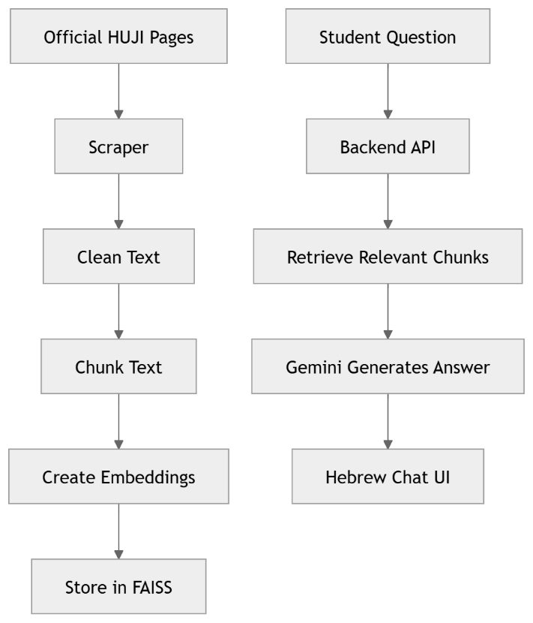
7. Phase 2 — Data Enrichment and Shnaton Integration
Timeline: Weeks 4–6
The second phase focused on expanding the system’s knowledge base.
7.1 The Main Challenge
The initial chatbot covered the main Business School pages, but the detailed course catalog was located inside the Hebrew University Shnaton system.
The Shnaton is a React single-page application. This means the content is not available directly inside the static HTML. Instead, the page loads course data dynamically through JavaScript API calls.
Standard scraping methods were not enough.
7.2 Technical Discovery
We used Playwright to inspect and intercept the network requests made by the Shnaton website. Through this process, we discovered internal API endpoints that provide structured academic data.
The three key endpoint types were:
Endpoint | Data Provided
/api/yearly-roadmaps/{code}/thresholds | Program roadmaps and mandatory courses
/api/specializations/{code}/thresholds | Courses inside specialization tracks
/api/syllabus?courseCode={code}&year=2026 | Full course syllabus details
7.3 Data Expansion
The knowledge base expanded significantly:
Source Type | Count | Description
MBA roadmaps | 7 | MBA programs and tracks
Specializations | 20 | Specialization tracks
Course catalog | 162 courses | Course names used in planner
Indexed chunks | 405 | Full searchable knowledge base

7.4 Course Data Now Included
The system can now answer questions using rich course-level data, including:
- Course code
- Course name
- Credits
- Semester
- Teacher name
- Class schedule
- Grade breakdown
- Course description
- Prerequisites
- Office hours, when available
7.5 Outcome of Phase 2
At the end of Phase 2, the chatbot became much more useful. It could answer detailed questions such as:
- Who teaches a specific course?
- When does the course take place?
- What is the grade breakdown?
- Which courses belong to a specialization?
- What are the requirements of a certain MBA track?

Shnaton Data Enrichment Flow:
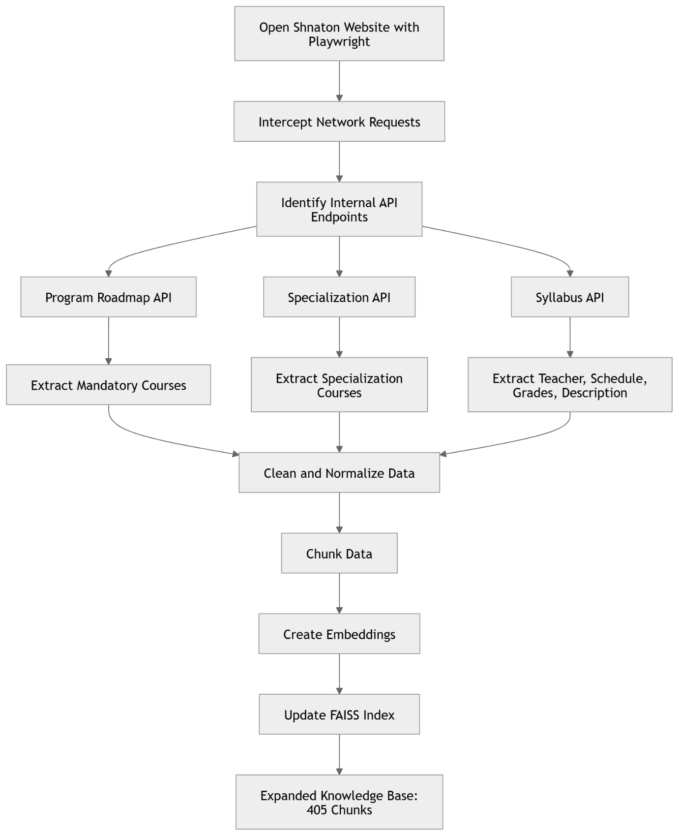

8. Phase 3 — UX, Quality, and Advanced Features
Timeline: Weeks 7–10
The third phase focused on making the system more usable, more reliable, and more personalized.

8.1 Quality Improvements
Problem 1: Citation Verifier False Positives
The original citation verifier checked whether quoted text appeared exactly in the retrieved context. However, Hebrew abbreviations such as ד"ר include quotation marks. This caused the regex logic to incorrectly detect long quote spans and mark valid answers as unverified.
Solution
We changed the verification threshold so that only quotes longer than 100 characters are checked. This avoids false positives caused by short Hebrew abbreviations, names, and titles.

Problem 2: Raw Markdown Display
Gemini answers often included formatting such as:
- Bold text
- Lists
- Tables
- Headings
However, the frontend originally rendered these as plain text, causing users to see raw symbols like **bold** or table pipes.
Solution
We integrated marked.js to render Markdown as HTML inside chat bubbles. We also added CSS styling for:
- Tables
- Headings
- Lists
- Bold text
- Hebrew right-to-left formatting

8.2 Onboarding Wizard
The onboarding wizard collects student context before the first message. This allows the chatbot to generate more personalized answers.
5-Step Flow
- Who are you?
Active student, prospective student, or alumni
- What year are you in?
Year 1, Year 2, or not relevant
- Are you doing two specializations?
Yes or no
- Choose main specialization
The student selects the primary specialization
- Choose secondary specialization
This appears only if the student selected two specializations
The student profile is silently added to every prompt.
Example:
[Student profile: Active MBA student | Year 1 | Main specialization: Finance and Banking | Secondary specialization: FinTech]
This allows the chatbot to answer questions based on the student’s actual academic situation.

Onboarding Wizard Logic:
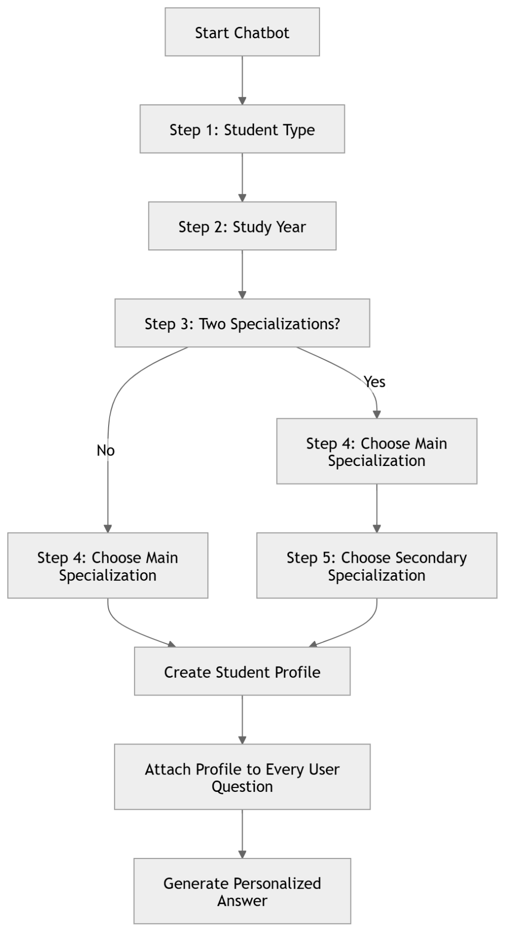

8.3 Course Schedule Planner
The course schedule planner turns the chatbot from a simple Q&A tool into an academic planning assistant.
Main Features
Feature | Description
Four-semester layout | Year 1 Semester A, Year 1 Semester B, Year 2 Semester A, Year 2 Semester B
Add courses | Students can add courses to each semester
Live autocomplete | Course suggestions appear while typing
Remove courses | One-click course removal
Clear all | Confirmation before deleting the plan
Responsive UI | Adapts to smaller screens

Autocomplete Logic
The autocomplete feature works as follows:
- Backend exposes a /courses endpoint
- The endpoint parses the indexed chunks
- Course names are extracted using regex
- The frontend fetches course names when the planner opens
- Course names are cached in memory
- User typing triggers client-side filtering
- Top matching courses are shown in a dropdown
The planner currently uses 162 real course names from the academic catalog.

Course Planner Flow
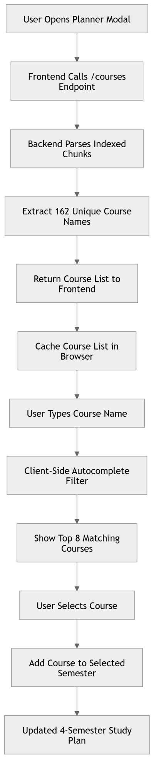

9. Full User Journey
The full user journey combines onboarding, personalized Q&A, source-grounded answer generation, and study planning.
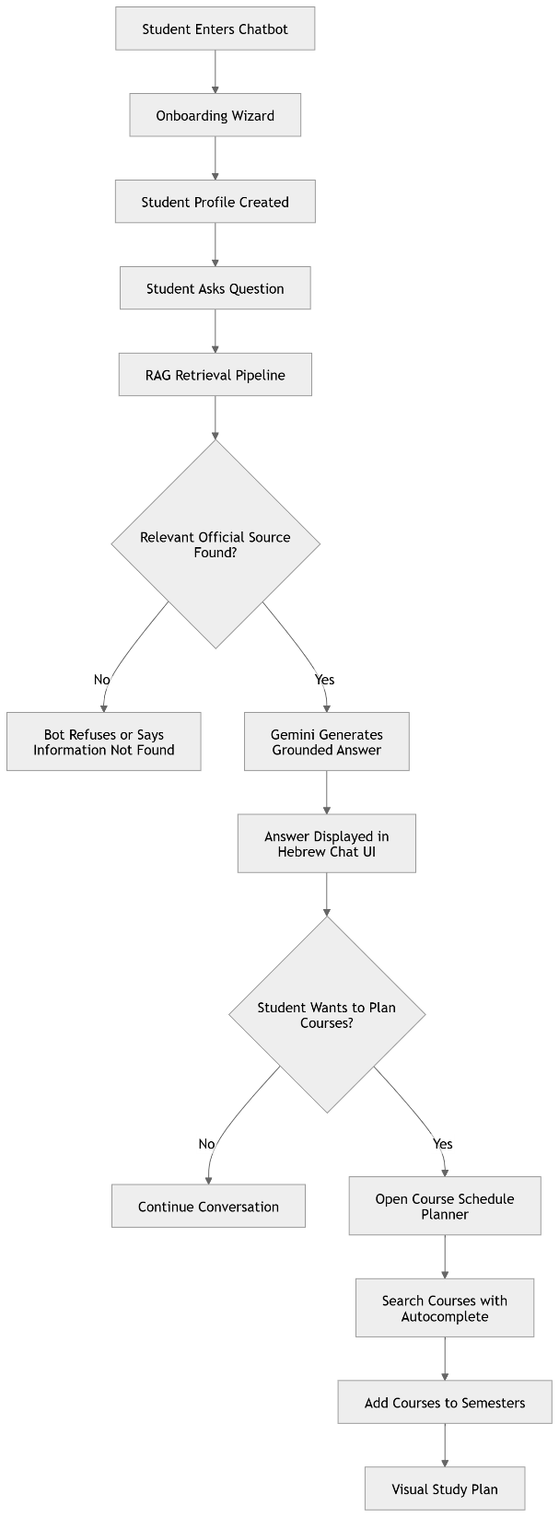

Week | Dates | Main Milestone
Weeks 1–2 | Early April | FastAPI server, Gemini integration, basic Hebrew chat UI
Week 3 | Mid April | RAG pipeline, embeddings, FAISS, off-topic gate
Week 4 | Late April | Scraping official Business School pages
Week 5 | Early May | Reverse-engineering Shnaton APIs
Week 6 | Mid May | Syllabus enrichment and 405 indexed chunks
Week 7 | Late May | Citation verifier fix and Markdown rendering
Week 8 | May 21–28 | Onboarding wizard and schedule planner
Week 9 | May 28 | Course autocomplete and final UI polish

11. Progress Summary
Step 1 — We Built the Foundation
We built a real AI academic advisor, not just a generic chatbot. The system uses Gemini, but every answer is grounded in official Hebrew University sources. The official content is scraped, chunked, embedded, and stored in FAISS. When a student asks a question, the system retrieves the most relevant chunks and then asks Gemini to answer only from that context.
This is important because it reduces hallucinations and makes the chatbot suitable for academic advising.

Step 2 — We Integrated the Hard Data Source: Shnaton
The most technically difficult part was extracting data from the Shnaton. The Shnaton is a React single-page application, so normal scraping does not capture the course data.
We used Playwright to inspect the internal API calls and discovered endpoints that provide program roadmaps, specialization requirements, and full syllabus data.
This expanded the system from about 50 chunks to 405 indexed chunks and allowed the chatbot to answer detailed course questions.

Step 3 — We Made the Bot Personalized
We added an onboarding wizard that collects student context before the conversation begins.
The bot now knows whether the user is:
- A prospective student
- An active student
- Alumni
- Year 1 or Year 2
- Studying one specialization or two
- In a specific main and secondary specialization
This makes the answers more relevant and closer to what a human academic advisor would provide.

Step 4 — We Added a Study Planner
We built a visual course schedule planner where students can organize courses across four semesters. The planner includes live autocomplete from the real academic course catalog.
This changes the product from a simple Q&A chatbot into a practical academic planning assistant.

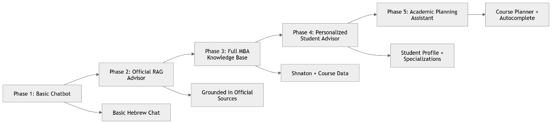

12. Remaining Work Plan
May 28 – June 22
Week | Dates | Focus | Deliverables
Week 1 | May 28 – June 1 | Evaluation and testing | Run 20+ test questions and document weak answers
Week 2 | June 2 – June 8 | Fine-tuning and fixes | Improve prompt, fix weak answers, update missing data
Week 3 | June 9 – June 15 | Business meeting and polish | Present to Ran, collect feedback, polish UI
Week 4 | June 16 – June 22 | Final delivery | Final testing, documentation, demo, deployment-ready build

13. Remaining Work — Detailed Plan
Week 1: Evaluation and Testing
During this week, we will test the chatbot across the most important academic use cases.
Test categories:
- Admission requirements
- Exemptions
- Course details
- Specialization rules
- Teacher and schedule questions
- Grade breakdowns
- Accelerated tracks
- Off-topic questions
Each answer will be graded as:
- Correct
- Partially correct
- Wrong
- Unsupported source
The goal is to identify gaps in the knowledge base or weaknesses in the prompting logic.

Week 2: Fine-Tuning and Fixes
During this week, we will improve the system based on the evaluation results.
Main tasks:
- Improve the system prompt
- Fix weak answer patterns
- Add missing sources if needed
- Improve formatting for multi-part questions
- Re-test all failed cases
The goal is to improve reliability before the business meeting.

Week 3: Business Meeting and UI Polish
During this week, we will prepare and present the product progress to Ran.
The demo should show:
- Onboarding wizard
- Regular academic question
- Course-specific question
- Off-topic refusal
- Course planner
- New conversation reset
After the meeting, we will collect feedback and implement only the highest-priority changes.

Week 4: Final Delivery
The final week will focus on stability, documentation, and delivery.
Main tasks:
- Freeze new features
- Run final testing
- Clean code
- Complete documentation
- Prepare final demo
- Submit final build by June 22

Final Conclusion
The MBA Academic Advisor Chatbot is no longer just a basic AI chat interface. It has become a structured academic advising system that combines official university data, retrieval-based AI, student personalization, and course planning.
The main value of the system is that it allows students to receive fast, relevant, and grounded answers without manually searching through fragmented university resources. From the university’s perspective, it can reduce repetitive administrative questions and improve the student experience.
The strongest technical contribution is the RAG architecture combined with Shnaton data integration. This enables the chatbot to answer detailed academic questions using real program, specialization, and course information.
The next stage is to complete evaluation, fine-tune the answer quality, collect business feedback, and prepare the final delivery by June 22.

